Name: Poorab Gangwani

Section: 2B

Enrollment #: CS191092

**LAB # 6**

**Experimental verification of P-N Junction diode characteristics**

**Lab Objectives:**

* To verify the forward bias V-I characteristics of a p-n junction diode.
* To verify the reverse bias V-I characteristics of a p-n junction diode.
* To verify that a p-n junction diode is a non-linear device.

**Apparatus Required:**

* DC Power Supply
* Digital Multi-meter
* Silicon Diode IN4007
* Resistors 1K ohm
* Connecting wires
* Bread board

**PRE-LAB**

**P-N Junction Diode:**

In electronics, a diode is a two-terminal electronic component with an asymmetric transfer characteristic, with low (ideally zero) resistance to current flow in one direction, and high (ideally infinite) resistance in the other. A semiconductor diode, the most common type today, is a crystalline piece of semiconductor material with a p-n junction connected to two electrical terminals.

The most common function of a diode is to allow an electric current to pass in one direction (called the diode's forward direction), while blocking current in the opposite direction (the reverse direction).

The most common type of diode is a ‘silicon diode.’ It is enclosed in a glass cylinder with the dark band marking the cathode terminal. This line points towards the positive of a circuit. The opposite terminal is called the anode.

Generally, diodes do not conduct until the voltage reaches approximately **0.7 volts**; this is called the **‘threshold point’** or **‘Knee Voltage’** or **‘Cut-in Voltage’.**

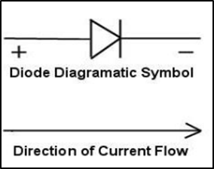

*Fig. 6.1: diode symbol*

**Current–Voltage Characteristic of a Diode:**

The most important diode characteristic is its current-voltage (*i-v*) relationship. This defines what the current running through a component is, given what voltage is measured across it. Resistors, for example, have a simple, linear *i-v* relationship (Ohm’s Law).

The *i-v* curve of a diode, though, is entirely non-linear. It looks something like this:

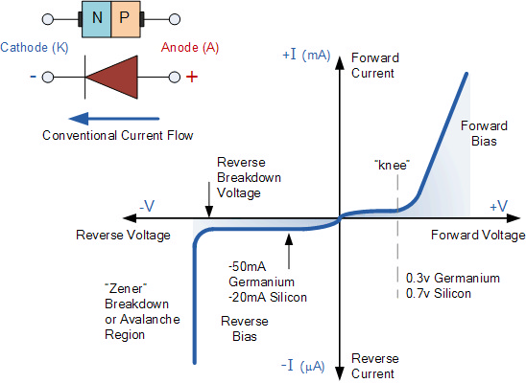

*Fig 6.2: voltage-current characteristic curve of a diode*

Depending on the voltage applied across it, a diode will operate in one of three regions:

1. **Forward bias**: When the voltage across the diode is positive the diode is “on” and current can run through. The voltage should be greater than the **forward voltage (VF)** usually 0.3V for germanium based diode and 0.7V for silicon in order for the current to be anything significant.
2. **Reverse bias**: This is the “off” mode of the diode, where the voltage is less than VF but greater than -VBR. In this mode current flow is (mostly) blocked, and the diode is off. A very small amount of current (on the order of Nano Amperes) – called **reverse saturation current** – is able to flow in reverse through the diode.
3. **Breakdown**: When the voltage applied across the diode is very large and negative, lots of current will be able to flow in the reverse direction, from cathode to anode. For normal diodes this breakdown voltage is around -50V to -100V, or even more negative.

**IN-LAB**

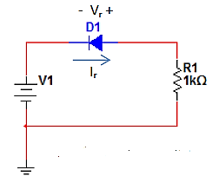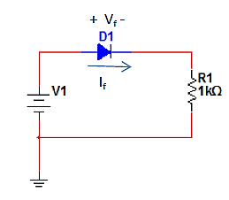

*Fig. 6.3: forward bias circuit Fig. 6.4: reversed bias circuit*

**LAB TASK 1:**

1. Draw the circuit shown in **fig 6.3** on breadboard.
2. Increase the voltage of the voltage source (V1) from 0V to 3V in steps of 0.1V. For each Observation, record the current (If) flowing through the circuit and the voltage drop (Vf) across the diode. Fill in **table 6.1.**

**LAB TASK 2:**

1. Draw the circuit shown in **fig 6.4** on breadboard.
2. Increase the voltage of the voltage source (V1) from 0V to 3V in steps of 0.1V. For each Observation, record the current (Ir) flowing through the circuit and the voltage drop (Vr) across diode. Fill in **table 6.1.**

**LAB TASK 3:**

1. Plot the voltage across diode versus the current flowing through it for both cases forward biased and reversed biased using the values from **table 6.1**. Plot the voltage on the X-axis and the current on the Y-axis.

|  |  |  |  |  |
| --- | --- | --- | --- | --- |
| **Source**  **Voltage** | **Observed Current (If) during F.B** | **Voltage Drop Across Diode (Vf) during F.B** | **Observed Current (Ir) during R.B** | **Voltage Drop Across Diode (Vr) During R.B** |
| 0.1v | 0.000052mA | 99.947mv | 0.0000061 | 99.994mv |
| 0.2v | 0.00049mA | 199.506mv | 0.0000069 | 199.993mv |
| 0.3v | 0.0039mA | 296.059mv | 0.0000070 | 299.993mv |
| 0.4v | 0.0225mA | 377.487mv | 0.0000070 | 399.993mv |
| 0.5v | 0.0696mA | 430.316mv | 0.0000070 | 499.992mv |
| 0.6v | 0.1378mA | 462.201mv | 0.0000070 | 599.992mv |
| 0.7v | 0.2166mA | 483.36mv | 0.0000070 | 699.992mv |
| 0.8v | 0.301259mA | 498.776mv | 0.0000070 | 799.992mv |
| 0.9v | 0.38924mA | 510.766mv | 0.0000070 | 899.992mv |
| 1v | 0.4795mA | 520.52mv | 0.0000070 | 999.992mv |
| 1.1v | 0.5713mA | 528.715mv | 0.0000070 | 1100mv |
| 1.3v | 0.7580mA | 541.949mv | 0.0000070 | 1300mv |
| 1.5v | 0.9476mA | 552.392mv | 0.0000070 | 1500mv |
| 1.7v | 1.139mA | 561.002mv | 0.0000070 | 1700mv |
| 1.9v | 1.332mA | 568.317mv | 0.0000070 | 1900mv |
| 2.1v | 1.525mA | 574.672mv | 0.0000070 | 2100mv |
| 2.3v | 1.72mA | 580.288mv | 0.0000070 | 2300mv |
| 2.5v | 1.915mA | 585.317mv | 0.0000070 | 2500mv |
| 2.7v | 2.11mA | 589.869mv | 0.0000070 | 2700mv |
| 2.9v | 2.306mA | 594.026mv | 0.0000070 | 2900mv |
| 3v | 2.404mA | 595.977mv | 0.0000070 | 3000mv |

*Table 6.1: voltage-current characteristics of diode*

**Conclusion:**

**__________________________________________________________________**

**__________________________________________________________________**

**__________________________________________________________________**

Name: Poorab Gangwani

Enrollment #: CS191092

**POST-LAB ASSIGNMENT # 6**

**Q.1)** Is the characteristic curve of diode linear?

__________________NO________________________________________________________

**Q.2)** What are the applications of diodes?

Applications of diodes are Rectification of AC to DC power, performing digital logic operations

Clipping circuits and reverse current protection.

**Q.3)** What is Reverse Breakdown Voltage?

It refers to the voltage required to overcome the natural tendency of a P-N junction to conduct in a reverse direction.

**Q.4)** Determine whether the diode is forward biased or reversed biased?

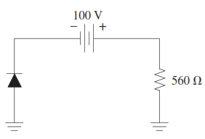

Forward Bias

__________________________________________________________________________



